Required Assignment 6.3:   
Design a Research Plan for Concept Testing a New Product

**Rupam Chatterjee**

**Suggested time:** 120 minutes

**Assignment Instructions**

The assignment is divided into 2 parts:

1. In a few sentences, define a new product concept you would like to test

Many people loves drinking coffee in their workspace or in their homes. Some prefer filtered or fresh brewed or prefer to order from online stores like Starbucks. A sophisticated generation of coffee lovers like light and dark roasted beans. They prefer to order from overseas brands which sometimes are difficult. Sometimes the order takes a month to reach the customers or they have to wait.

So “COFFER” is a one place online store solution which has been launched for both android and IPhone users. It is a virtual store cum online marketplace where customers can buy coffee beans or can order online drinks with different flavor .Delivery is free within 3 kms. Customers can register themselves or can shop or order from the APP. COFFER will bring the best Arabica beans, Heirloom Varietals**,** Piemonte from South America and Arabia which is not available in Indian markets. COFFER will enter into a partnership with LAVEZZE to sell online COFFEE. Marketed towards adults primarily targeting professionals, millennials who have a nack of drinking coffee. COFFER is also offering free Mug with first order and have reward points

1. Define how you would test the concept through customer responses. This step should consist of elements you would test (Two of which are mentioned above (intent and frequency). You have to come up with one more element that should be tested). Also show the questionnaire consisting of one question each for each element.

**GOAL:**

**Wireframe usability test:** assess a website interface’s usability and identify potential issues before launch

**Preference test**: ask people to choose between two or more concepts, and explain their preference

**Pricing test**: gauge how existing or potential customers react to different pricing options

**APP UX and Localization** : gauge user’s interest in the uniqueness of the product

**Target Market:**

Target your concept test to new trial users which will include male adults 25 -45 by sending them a online “[Survey Link](https://help.hotjar.com/hc/en-us/articles/115011787508-What-is-a-Hotjar-Survey-#link)” by email. We will arrange an online webinar and will share the videos through digital storyboard in local café’s, Facebook, Twitter, Insta and LinkedIn. We will invite customers to register through our e-marketing team for the survey

**Testing the Concept:**

Sequential Monadic Testing to be taken where the target audience is split into multiple groups. Each group is presented with all the concepts in a randomly order.Idea is to test multiple concepts in 1 cycle. The respondents will be asked the same set of follow-up questions for each concept to get further insights.We are going to take the App Logo , HomeScreen And MarketPlace UX for concept testing .Will do an On premises interview at central malls and present the concepts with the group . They will be given a interactive video about the journey of the concept.each team will be presented with interactive journey of the concept

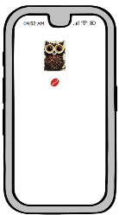

LOGO

**SURVEY**

Contact them in advance and letting them know that we are arranging an on premises interview at a shopping Mall and will be presented with Goodie bag at the end of the survey program

How visually appealing is the online marketplace

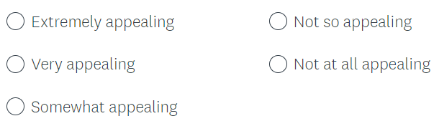

How Likely you are going to buy from COFFER if we launch today

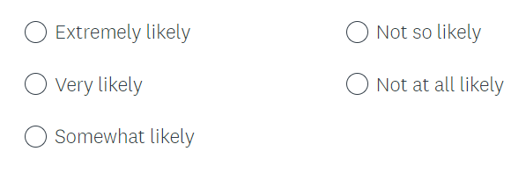

How frequently will you shop from COFFER ?

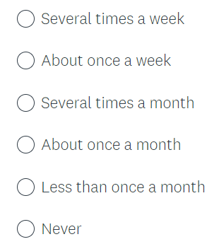

How would you like to try our traditional Filter coffee made from arabica beans at 250 ?

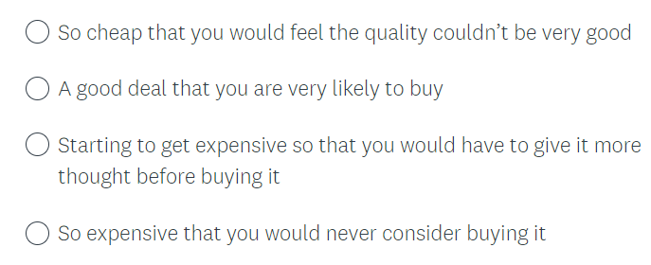

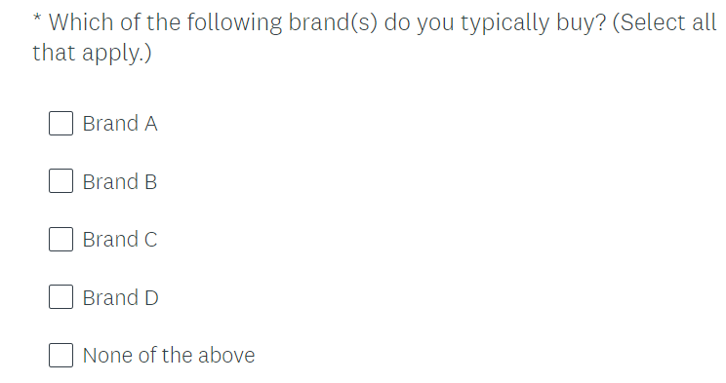

Communicating the concept: REELS of the product to be presnted to the consumers which wil tell our story

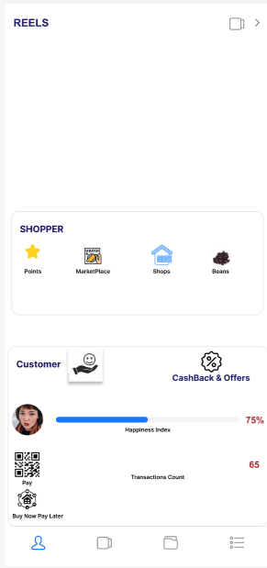

Responses

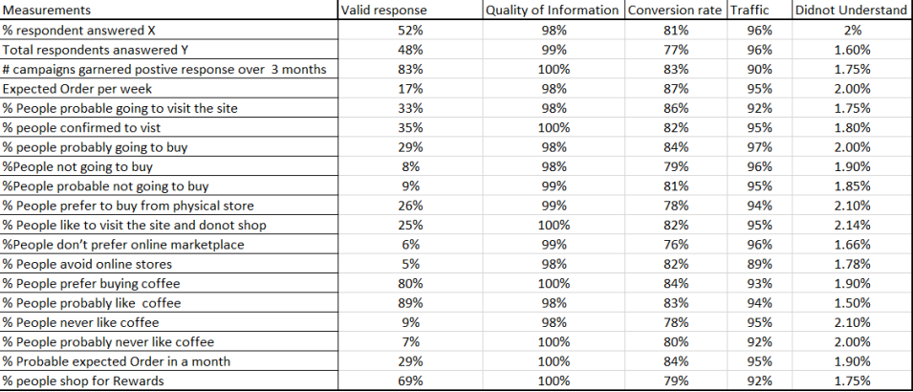

***Note****: This is a required assignment and counts towards programme completion.*